MED D - How to Identify a Coverage Determination (CD) on Member’s Account

PeopleSafe Research Process
Related Documents

Description: This document describes how a Customer Care Representative (CCR) can identify if there is an existing Coverage Determination on a member’s account.

If an active PBO/Prior Authorization is in the system for the drug (ex. A Clinical PA), do not enter an override. PA Edits are ONLY to be done by the Senior Team.

PeopleSafe Research Process

The information and screenshot below provide indicators to look for to determine if there is an existing PA on the account:
Step | Action
1 | On the Main screen in PeopleSafe, scroll down to the desired rejected claim.
2 | Click on the Prescription number hyperlink.  Result: Prescription Detail screen.
3 | On the Prescription Detail screen, scroll down to the Rejection code section and verify if the claim is rejecting for Refill-Too-Soon.
4 | Determine if the system shows a PA for the medication:  - Verify the GPI number on the claim (copy and paste into notepad).  - Review the claim to see if a PA is showing under the Override Type ID field.  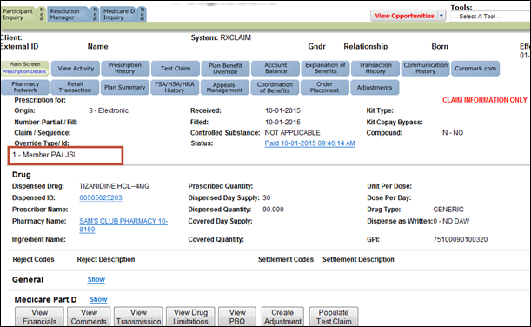  - If a PA does not show on the claim, review the PBO Tab.
5 | - Select the tab  - On the Plan Benefit Override screen, verify if there is a PBO with the GPI that matches the claim (check the GPI that you copied into notepad from the above step).  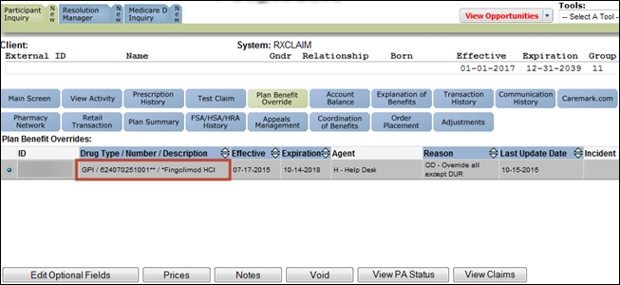
5 | If PA is… | Then…
5 | In the System | Transfer to the Senior Team.  Refer to MED D - When to Transfer Calls to the Senior Team.
5 | Not in the System | If CIF allows, proceed with entering the override. Refer to Plan Benefit Overrides (PBO) CCR.

Top of the Document

Related Documents
Parent SOP: CALL-0048: Medicare Part D Customer Care Call Center Requirements-CVS Caremark Part D Services, L.L.C.
Abbreviations/Definitions: Abbreviations / Definitions

Top of the Document
Not To Be Reproduced Or Disclosed to Others Without Prior Written Approval
ELECTRONIC DATA = OFFICIAL VERSION – PAPER COPY = INFORMATIONAL ONLY

